

Asia Pacific College

#3 Humabon Place, Magallanes, Makati City

SCHOOL OF COMPUTING AND INFORMATION TECHNOLOGIES

Bachelor of Science in Information Technology

Major in Mobile and Internet Technology

**AfterLife**

**(Management of the Dead and the Missing Person System)**

Submitted to:

Mr. Edmundo G. Casiño

In partial fulfillment of the Requirements for Quality Assurance

Submitted by:

Kyle Vincent V. Lee

Hannah Mae E. Reyes

MI – 141

April 27, 2017

**Table of Contents**

[I. Introduction 4](#_Toc481073928)

[a. Objectives 4](#_Toc481073929)

[b. Purpose 4](#_Toc481073930)

[II. References 5](#_Toc481073931)

[III. Modules 7](#_Toc481073932)

[IV. Test Plan 8](#_Toc481073933)

[a. Testing Strategy 8](#_Toc481073934)

[b. Test Checklist 8](#_Toc481073935)

[Web Application 8](#_Toc481073936)

[Database Design 13](#_Toc481073937)

[User Interface 14](#_Toc481073938)

[Security 16](#_Toc481073939)

[Search for Dead/Missing Person 18](#_Toc481073940)

[Log-in 19](#_Toc481073941)

[Sign-up 21](#_Toc481073942)

[c. Test Risks/Issues 22](#_Toc481073943)

[d. Items to be tested 23](#_Toc481073944)

[e. Test Approach 24](#_Toc481073945)

[f. Test Pass/Fail Criteria 25](#_Toc481073946)

[h. Test Cases 27](#_Toc481073947)

[Log-in 27](#_Toc481073948)

[Sign-up 28](#_Toc481073949)

[Search for Dead 31](#_Toc481073950)

[Search for Missing 32](#_Toc481073951)

[Dead Identification Form 34](#_Toc481073952)

[Missing Person Form 38](#_Toc481073953)

[Request Resource 43](#_Toc481073954)

[i. Number of Items Tested 45](#_Toc481073955)

[Number of Pass Tests 45](#_Toc481073956)

[Number of Fail Tests 45](#_Toc481073957)

[j. Test Ratings 46](#_Toc481073958)

[Pass Rate 46](#_Toc481073959)

[Defect Rate 46](#_Toc481073960)

[k. Test Results 47](#_Toc481073961)

[Overall Results 47](#_Toc481073962)

[V. Appendices 48](#_Toc481073963)

[Appendix 1: Curriculum Vitae 48](#_Toc481073964)

# [**I. Introduction**](http://projects2.apc.edu.ph/wiki/index.php/Management_of_the_Dead_and_Missing_Person_System#Introduction)

Quality Assurance is an important part of project making and software development. It ensures that the product to be delivered is or will reach certain standards of the client/users.

This document will serve as a basis to see if the proposed system is functional at all parts and reached the standards of the user who will use the system. It includes the tests that are going to be used in the system, the results of the tests, and the parts that are not going to be tested for quality.

This document gives a view on how the system is functioning now and what areas of the system needs improvement.

* The first section illustrates all the modules that the system contains.
* The second section shows the strategy of the team in testing, it includes the checklist, risks and issues, the items to be tested, the testing approach, criteria for passing and failing tests, and the entry and exit criteria.
* The third section shows all the test cases done.
* The fourth section shows all the results that the team got from all the testing made in the project.

## [**a. Objectives**](http://projects2.apc.edu.ph/wiki/index.php/Management_of_the_Dead_and_Missing_Person_System#Objectives)

This Software Quality Assurance (SQA) was created with the following objectives:

* Minimal Defects

One of the primary goals of the SQA is to minimalize, if not completely eradicate errors in the system using universally approved steps. Lesser errors will most likely result to smoother flow of the system once produced.

* Customer Satisfactions

Also, a goal of the SQA is to ensure that the customer will be satisfied with the system.

* Well Structured

Not everyone is able to build an application that could be understood well. The SQA ensures that the system is built in an understandable manner.

## [**b. Purpose**](http://projects2.apc.edu.ph/wiki/index.php/Management_of_the_Dead_and_Missing_Person_System#Purpose)

This document overviews the quality standards for the Management of the Dead and the Missing Persons System and other project deliverables. These standards are obtained from software requirements, software architecture documents and follow the requirement of the stakeholders.

# [**II. References**](http://projects2.apc.edu.ph/wiki/index.php/Management_of_the_Dead_and_Missing_Person_System#References)

*Check list about General - Navigation.* (2017). Sqa.fyicenter.com. Retrieved 13   
 April 2017, from [http://sqa.fyicenter.com/FAQ/Software-Testing-Check- List/Check\_list\_about\_General\_Navigation.html](http://sqa.fyicenter.com/FAQ/Software-Testing-Check-List/Check_list_about_General_Navigation.html)

*Check list about General - Search Capabilities.* (2017). Sqa.fyicenter.com. Retrieved 14 April 2017, from <http://sqa.fyicenter.com/FAQ/Software-Testing-Check-List/Check_list_about_General_Search_Capabilities.html>

*Test Cases for Login Screen Page. (2017).* Onecore. Retrieved 13 April 2017, from <http://onecore.net/test-cases-for-login-screen-page.htm>

*Web Site Testing Checklist - Tables.* (2017). Sqa.fyicenter.com. Retrieved 14 April 2017, from <http://sqa.fyicenter.com/FAQ/Software-Testing-Check-List/Web_Site_Testing_Checklist_Tables.html>

*Web Site Testing Checklist - Usability, Interfac.* (2017). Sqa.fyicenter.com. Retrieved 14 April 2017, from <http://sqa.fyicenter.com/FAQ/Software-Testing-Check-List/Web_Site_Testing_Checklist_Usability_Interfac.html>

*Web Site Testing Checklist: General.* (2017). Sqa.fyicenter.com. Retrieved 13 April 2017, from <http://sqa.fyicenter.com/FAQ/Software-Testing-Check-List/Web_Site_Testing_Checklist_General.html>

*Web Testing Checklist - General.* (2017). Sqa.fyicenter.com. Retrieved 13 April 2017, from  <http://sqa.fyicenter.com/FAQ/Software-Testing-Check-List/Web_Testing_Checklist_General.html>

*Web Testing Checklist - Operating systems Enviro.* (2017). Sqa.fyicenter.com. Retrieved 13 April 2017, from <http://sqa.fyicenter.com/FAQ/Software-Testing-Check-List/Web_Testing_Checklist_Operating_systems_Enviro.html>

*Web Testing Checklist - Risk and Hardware.* (2017). Sqa.fyicenter.com. Retrieved 13 April 2017, from <http://sqa.fyicenter.com/FAQ/Software-Testing-Check-List/Web_Testing_Checklist_Risk_and_Hardware.html>

*Web Testing Checklist about Compatibility and Po.* (2017). Sqa.fyicenter.com. Retrieved 13 April 2017, from <http://sqa.fyicenter.com/FAQ/Software-Testing-Check-List/Web_Testing_Checklist_about_Compatibility_and_Po.html>

*Web Testing Checklist about Correctness - Data.* (2017). Sqa.fyicenter.com. Retrieved 13 April 2017, from <http://sqa.fyicenter.com/FAQ/Software-Testing-Check-List/Web_Testing_Checklist_about_Correctness_Data.html>

*Web Testing Checklist about Correctness - Presen.* (2017). Sqa.fyicenter.com. Retrieved 13 April 2017, from <http://sqa.fyicenter.com/FAQ/Software-Testing-Check-List/Web_Testing_Checklist_about_Correctness_Presen.html>

*Web Testing Checklist about Performance - Archit.* (2017). Sqa.fyicenter.com. Retrieved 13 April 2017, from http://sqa.fyicenter.com/FAQ/Software-Testing-Check-List/Web\_Testing\_Checklist\_about\_Performance\_Archit.html

*Web Testing Checklist about Security - Access Co.* (2017). Sqa.fyicenter.com. Retrieved 13 April 2017, from <http://sqa.fyicenter.com/FAQ/Software-Testing-Check-List/Web_Testing_Checklist_about_Security_Access_Co.html>

*Web Testing Checklist about Security - Data Secu.* (2017). Sqa.fyicenter.com. Retrieved 13 April 2017, from <http://sqa.fyicenter.com/FAQ/Software-Testing-Check-List/Web_Testing_Checklist_about_Security_Data_Secu.html>

*Web Testing Checklist about Security - Privacy.* (2017). Sqa.fyicenter.com. Retrieved 13 April 2017, from <http://sqa.fyicenter.com/FAQ/Software-Testing-Check-List/Web_Testing_Checklist_about_Security_Privacy.html>

*Web Testing Checklist about Usability.* (2017). Sqa.fyicenter.com. Retrieved 13 April 2017, from <http://sqa.fyicenter.com/FAQ/Software-Testing-Check-List/Web_Testing_Checklist_about_Usability.html>

*What is Software Quality Assurance? | IT Training and Consulting – Exforsys.* (2017). Exforsys.com. Retrieved 14 April 2017,from  <http://www.exforsys.com/tutorials/sqa/what-is-software-quality-assurance.html>

# [**III. Modules**](http://projects2.apc.edu.ph/wiki/index.php/Management_of_the_Dead_and_Missing_Person_System#Modules)

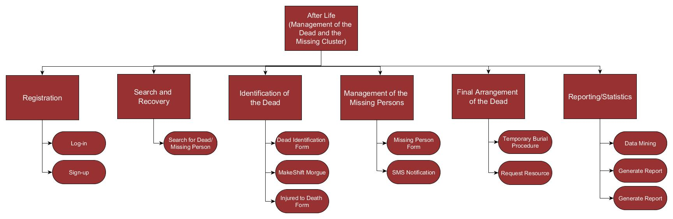

# [**IV. Test Plan**](http://projects2.apc.edu.ph/wiki/index.php/Management_of_the_Dead_and_Missing_Person_System#Test_Plan)

## [**a. Testing Strategy**](http://projects2.apc.edu.ph/wiki/index.php/Management_of_the_Dead_and_Missing_Person_System#Testing_Strategy)

Testing for the Management of the Dead and the Missing Persons’ System project seeks to accomplish two main goals:

1. Detect failures and defects in the system
2. Detect inconsistency between requirements and implementation

To achieve these goals, the testing strategy for the system will consist of three testing levels. These are unit testing, integration testing, and acceptance testing. The following subsections outline these testing levels, which development team roles are responsible for developing and executing them, and criteria for determining their completeness.

## [**b. Test Checklist**](http://projects2.apc.edu.ph/wiki/index.php/Management_of_the_Dead_and_Missing_Person_System#Test_Checklist)

### [**Web Application**](http://projects2.apc.edu.ph/wiki/index.php/Management_of_the_Dead_and_Missing_Person_System#Web_Application)

|  |  |  |  |  |  |
| --- | --- | --- | --- | --- | --- |
| **APPLICATION QUALITY ASSURANCE CHECKLIST** | | | | | |
| **Application Name:** | Management of the Dead and the Missing Persons' System | | | | |
| **Project Manager:** | Hannah Mae E. Reyes | | | | |
| **Date Completed:** |  | | | | |
|  |  |  |  |  |  |
| **Item No.** | **Validation Questions** | **Yes** | **No** | **N.A.** | **Remarks** |
| **1** | **Functionality** | | | | |
| **1.1** | **Links** | | | | |
| 1.1.1 | Are all link takes you to the page it said it would? |  |  |  |  |
| 1.1.2 | Is it ensure that there are no orphan pages (a page that has no links to it)? |  |  |  |  |
| 1.1.3 | Are all referenced web sites or email addresses hyperlinked? |  |  |  |  |
| 1.1.4 | Are all mail to links reaches the right recipient? |  |  |  |  |
| **1.2** | **Forms** | | | | |
| 1.2.1 | Is all acceptance of invalid input correct? |  |  |  |  |
| 1.2.2 | Does all mandatory fields return an error when you don't have an input? |  |  |  |  |
| 1.2.3 | Is there an error when you input longer than field allows? |  |  |  |  |
| 1.2.4 | Are all radio buttons working? |  |  |  |  |
| 1.2.5 | Is all the data inside combo/list box are arranged in chronological order? |  |  |  |  |
| 1.2.6 | Are all the parts of a table or form present? Correctly laid out? Can you confirm that selected texts are in the right place? |  |  |  |  |
| 1.2.7 | Are the functionality of buttons available on all pages? |  |  |  |  |
| 1.2.8 | Does a scrollbar appear if required? |  |  |  |  |
| **1.3** | **Image Upload Functionality** | | | | |
| 1.3.1 | Are the image upload functionality with image files has different extensions (e.g. JPEG, PNG, BMP etc.)? |  |  |  |  |
| 1.3.2 | When the user upload with image size greater than the max allowed size, are there any proper error message displayed? |  |  |  |  |
| 1.3.3 | When the user upload image functionality with file types other than images (e.g. txt, doc, pdf, exe etc.), are there any proper error message displayed? |  |  |  |  |
| 1.3.4 | Can user able to use/view the uploaded images? |  |  |  |  |
| **2** | **Application Specific Functional Requirements** | | | | |
| **2.1.** | **Data Integration** | | | | |
| 2.1.1. | Does the system misbehaves when there is an invalid input? |  |  |  |  |
| **2.2** | **Date Field Checks** | | | | |
| 2.2.1 | Can the user see the previous dates? |  |  |  |  |
| 2.2.2 | Can the user see future dates? |  |  |  |  |
| 2.2.3 | Is the current date correct? |  |  |  |  |
| **2.3** | **Numeric Fields** | | | | |
| 2.3.1 | Are the lowest and highest values are handled correctly? |  |  |  |  |
| **2.4** | **Alphanumeric Field Checks** | | | | |
| 2.4.1 | Are all invalid characters & symbols included? |  |  |  |  |
| 2.4.2 | Are all valid characters included? |  |  |  |  |
| **3** | **Error Handling** | | | | |
| **3.1** | **Error Handling** | | | | |
| 3.1.1 | If we lose our Internet connection does the transaction cancel? |  |  |  |  |
| 3.1.2 | Does the application handle all the errors that could reasonably be expected to occur? |  |  |  |  |
| 3.1.3 | Do the error messages contain minimal but meaningful information? |  |  |  |  |
| 3.1.4 | Does the application avoid displaying system information in error messages? |  |  |  |  |
| 3.1.5 | Are the error messages kept in a single location? |  |  |  |  |
| **4** | **Compatibility** | | | | |
| **4.1** | **Browsers** | | | | |
| 4.1.1 | Is the HTML version being used compatible with appropriate browser versions? |  |  |  |  |
| 4.1.2 | Do images display correctly with browsers under test? |  |  |  |  |
| 4.1.3 | Does the fonts are usable on any of the browsers? |  |  |  |  |
| 4.1.4 | Is Java Code/Scripts usable by the browsers under test? |  |  |  |  |
| **4.2** | **Audience** | | | | |
| 4.2.1 | Is the application compatible with the audience experience level? |  |  |  |  |
| 4.2.2 | Where possible, has the audience readiness been ensured? |  |  |  |  |
| 4.2.3 | Are text version and/or upgrade links present? |  |  |  |  |
| **4.3** | **Testing Process** | | | | |
| 4.3.1 | Is the testing environment compatible with the operating systems of the audience? |  |  |  |  |
| **5** | **Usability** | | | | |
| **5.1** | **Navigation** | | | | |
| 5.1.1 | Is the flow to destination (page to page) logical? |  |  |  |  |
| 5.1.2 | Is the flow to destination the page top-bottom left to, right? |  |  |  |  |
| 5.1.3 | Is there a logical way to return? |  |  |  |  |
| 5.1.4 | Is navigation can be easily learned? |  |  |  |  |
| 5.1.5 | Is navigation available when needed (especially when the user is finished doing something)? |  |  |  |  |
| 5.1.6 | Is redundant navigation is avoided? |  |  |  |  |
| **5.2** | **Ease of Use** | | | | |
| 5.2.1 | Is there minimal scrolling and resizable screens? |  |  |  |  |
| 5.2.2 | Do menus load first? |  |  |  |  |
| 5.2.3 | Are messages understandable? |  |  |  |  |
| 5.2.4 | Are confirmation messages available as appropriate? |  |  |  |  |
| **6** | **Operating System Environment/Platform** | | | | |
| 6.1 | Has the operating environments and platforms been defined? |  |  |  |  |
| 6.2 | Have audience expectations been properly managed? |  |  |  |  |
| 6.3 | Have the business users/marketing been adequately prepared for what will be tested? |  |  |  |  |
| **7** | **Hardware** | | | | |
| 7.1 | Is the test hardware compatible with all screen types, sizes, resolution of the audience? |  |  |  |  |
| 7.2 | Is the test hardware compatible with all databases of the audience? |  |  |  |  |
| **8** | **Performance** | | | | |
| **8.1** | **Architecture** | | | | |
| 8.1.1 | Has the database capacity been identified? |  |  |  |  |
| 8.1.2 | Has the current system diagram been developed? |  |  |  |  |
| 8.1.3 | Have the types of programming languages been identified? |  |  |  |  |
| **9** | **Correctness** | | | | |
| **9.1** | **Data** |  |  |  |  |
| 9.1.1 | Does the application write to the database properly? |  |  |  |  |
| 9.1.2 | Does the application record from the database correctly? |  |  |  |  |
| 9.1.3 | Are text fields storing information correctly? |  |  |  |  |
| **9.2** | **Presentation** | | | | |
| 9.2.1 | Are the field data properly displayed? |  |  |  |  |
| 9.2.2 | Is the spelling correct? |  |  |  |  |
| 9.2.3 | Do the interfaces meet current GUI standards? |  |  |  |  |
| **10** | **Tables** | | | | |
| 10.1 | Does the user constantly scroll to the right to see items in a table? |  |  |  |  |
| 10.2 | Do tables print out properly? |  |  |  |  |
| **11** | **General** | | | | |
| 11.1 | Does the system do what it is intended to do? |  |  |  |  |
| 11.2 | Does it provide the correct results? |  |  |  |  |
| 11.3 | Does the system provide all the functions and features expected? |  |  |  |  |
| 11.4 | Is it easy to learn and use? |  |  |  |  |
| 11.5 | Can the system easily be modified or fixed? |  |  |  |  |
| 11.6 | Can the system be validated to prove it works in an acceptable manner? |  |  |  |  |
| 11.7 | Can some of the components be re-used in other systems? |  |  |  |  |
| 11.8 | Can the system be quickly and easily installed on a variety of platforms by a variety of users? |  |  |  |  |
| 11.9 | Is the application compatible with standards and conventions of the audience? |  |  |  |  |

### **[Database Design](http://projects2.apc.edu.ph/wiki/index.php/Management_of_the_Dead_and_Missing_Person_System" \l "Database_Design)**

|  |  |  |  |  |  |
| --- | --- | --- | --- | --- | --- |
| **APPLICATION QUALITY ASSURANCE CHECKLIST** | | | | | |
| **Application Name:** | Management of the Dead and the Missing Persons' System | | | | |
| **Project Manager:** | Hannah Mae E. Reyes | | | | |
| **Date Completed:** |  | | | | |
|  |  |  |  |  |  |
| **Item No.** | **Validation Questions** | **Yes** | **No** | **N.A.** | **Remarks** |
| **1** | **Backend** | | | | |
| 1.1 | Have the database tables been normalized? |  |  |  |  |
| 1.2 | Are keys based on sequence numbers have unique sequences? |  |  |  |  |
| 1.3 | Are all keys and required fields set to ‘not null’ in all tables of the database? |  |  |  |  |
| 1.4 | Are the delete functionality for any record on page ask for confirmation? |  |  |  |  |
| 1.5 | Does the Select/deselect all records options provided if page supports record add/delete/update functionality? |  |  |  |  |
| 1.6 | Are the correct data is getting saved in database upon successful page submit? |  |  |  |  |
| 1.7 | Does the data is committed to database only when the operation is successfully completed? |  |  |  |  |
| 1.8 | Are all database fields are designed with correct data type and data length? |  |  |  |  |
| 1.9 | Are all table constraints like Primary key, Foreign key etc. are implemented correctly? |  |  |  |  |

### [**User Interface**](http://projects2.apc.edu.ph/wiki/index.php/Management_of_the_Dead_and_Missing_Person_System#User_Interface)

|  |  |  |  |  |  |
| --- | --- | --- | --- | --- | --- |
| **APPLICATION QUALITY ASSURANCE CHECKLIST** | | | | | |
| **Application Name:** | Management of the Dead and the Missing Persons' System | | | | |
| **Project Manager:** | Hannah Mae E. Reyes | | | | |
| **Date Completed:** |  | | | | |
|  |  |  |  |  |  |
| **Item No.** | **Validation Questions** | **Yes** | **No** | **N.A.** | **Remarks** |
| 1 | **User Interface** | | | | |
| 1.1 | **Colors** | | | | |
| 1.1.1 | Are hyperlink colors standard? |  |  |  |  |
| 1.1.2 | Are the field backgrounds the correct color? |  |  |  |  |
| 1.1.3 | Are the field prompts the correct color? |  |  |  |  |
| 1.1.4 | Are all the buttons are in standard format and size? |  |  |  |  |
| 1.1.5 | Is the general screen background the correct color? |  |  |  |  |
| 1.1.6 | Is the page background (color) distraction free? |  |  |  |  |
| **1.2** | **Content** | | | | |
| 1.2.1 | Are all fonts same? |  |  |  |  |
| 1.2.2 | Are all the screen prompts specified in the correct screen font? |  |  |  |  |
| 1.2.3 | Does content remain if you need to go back to a previous page, or if you move forward to another new page? |  |  |  |  |
| 1.2.4 | Are all fields on page (e.g. text box, radio options, dropdown lists) aligned properly? |  |  |  |  |
| 1.2.5 | Is all text properly aligned? |  |  |  |  |
| 1.2.6 | Is the text in all fields specified in the correct screen font? |  |  |  |  |
| 1.2.7 | Is all the heading are left aligned? |  |  |  |  |
| 1.2.8 | Does the first letter of the second word appears in lowercase? |  |  |  |  |
| **1.3** | **Images** | | | | |
| 1.3.1 | Are all graphics properly aligned? |  |  |  |  |
| 1.3.2 | Are all command buttons being all similar size and shape, and same font & font size? |  |  |  |  |
| **1.4** | **Instructions** | | | | |
| 1.4.1 | Is all the error message text spelt correctly on this screen? |  |  |  |  |
| 1.4.2 | Is micro help text (i.e. tool tip) for every enabled field & button? |  |  |  |  |
| 1.4.3 | Is all the micro-help text (i.e. tool tip) spelt correctly on this screen? |  |  |  |  |
| **1.5** | **Navigation** | | | | |
| 1.5.1 | Are all disabled fields avoided in the TAB sequence? |  |  |  |  |
| 1.5.2 | Are all read-only fields avoided in the TAB sequence? |  |  |  |  |
| 1.5.3 | Does a scrollbar appear if required? |  |  |  |  |
| 1.5.4 | Is there a link to home on every single page? |  |  |  |  |
| **1.6** | **Usability** | | | | |
| 1.6.1 | Are fonts too large or too small to read? |  |  |  |  |
| 1.6.2 | Are names in command button & option box names are not abbreviations? |  |  |  |  |
| 1.6.3 | Are all option boxes, option buttons, and command buttons are logically grouped together in clearly demarcated areas "Group Box"? |  |  |  |  |
| 1.6.4 | Can the typical user run the system without frustration? |  |  |  |  |
| 1.6.5 | Does the site have a consistent, clearly recognizable "look-&-feel"? |  |  |  |  |
| 1.6.6 | Does the system provide or facilitate customer service? i.e. responsive, helpful, accurate? |  |  |  |  |
| 1.6.7 | Is all terminology understandable for all the site’s intended users? |  |  |  |  |
| **1.7** | **Forms** | | | | |
| 1.7.1 | Are all mandatory fields validated and indicated by asterisk (\*) symbol? |  |  |  |  |
| 1.7.2 | Are all dropdown fields have first entry as blank or text like ‘Select’? |  |  |  |  |

### [**Security**](http://projects2.apc.edu.ph/wiki/index.php/Management_of_the_Dead_and_Missing_Person_System#Security)

|  |  |  |  |  |  |
| --- | --- | --- | --- | --- | --- |
| **APPLICATION QUALITY ASSURANCE CHECKLIST** | | | | | |
| **Application Name:** | Management of the Dead and the Missing Persons' System | | | | |
| **Project Manager:** | Hannah Mae E. Reyes | | | | |
| **Date Completed:** |  | | | | |
|  |  |  |  |  |  |
| **Item No.** | **Validation Questions** | **Yes** | **No** | **N.A.** | **Remarks** |
| **1** | **Password** | | | | |
| 1.1 | Does the system have functionality to allow the user to revise their password? |  |  |  |  |
| 1.2 | Does the system support protected storage of passwords with privileged user access? |  |  |  |  |
| 1.3 | Does the system meet the standard password requirements? |  |  |  |  |
| 1.4 | Are the password and other sensitive fields masked while typing? |  |  |  |  |
| 1.5 | Are there any test password security and password policy enforcement? |  |  |  |  |
| **2** | **Function** | | | | |
| 2.1 | Does the application logout functionality works properly? |  |  |  |  |
| **3** | **Error Handling** | | | | |
| 3.1 | Are all error messages not reveal any sensitive information? |  |  |  |  |
| **4** | **Access Control** | | | | |
| 4.1 | Is there a defined standard for login names/passwords? |  |  |  |  |
| 4.2 | Are users locked out after a given number of password failures? |  |  |  |  |
| 4.3 | Is there a link for help (e.g., forgotten passwords?) |  |  |  |  |
| 4.4 | Have authorization levels been defined? |  |  |  |  |
| **5** | **Privacy** | | | | |
| 5.1 | Is sensitive data restricted to be viewed by unauthorized users? |  |  |  |  |
| 5.2 | Is proprietary content copyrighted? |  |  |  |  |
| 5.3 | Is the privacy policy communicated to users and customers? |  |  |  |  |
| **6** | **Data Security** |  |  |  |  |
| 6.1 | Are data access privileges identified? (e.g., read, write, update and query) |  |  |  |  |
| 6.2 | Have file permissions been established? |  |  |  |  |
| 6.3 | Have file permissions been tested? |  |  |  |  |

### [**Search for Dead/Missing Person**](http://projects2.apc.edu.ph/wiki/index.php/Management_of_the_Dead_and_Missing_Person_System#Search_for_Dead.2FMissing_Person)

|  |  |  |  |  |  |
| --- | --- | --- | --- | --- | --- |
| **APPLICATION QUALITY ASSURANCE CHECKLIST** | | | | | |
| **Application Name:** | Management of the Dead and the Missing Persons' System | **Date Completed:** | |  | |
| **Project Manager:** | Hannah Mae E. Reyes | **Module:** | | Search and Recovery | |
| **Sub Module:** | Search for Dead/Missing Person | | | | |
|  |  |  |  |  |  |
| **Item No.** | **Validation Questions** | **Yes** | **No** | **N.A.** | **Remarks** |
| **1** | **Filtering** | | | | |
| 1.1 | Can the user able to filter results using all parameters on the page? |  |  |  |  |
| 1.2 | Does the refine search functionality load search page with all user selected search parameters? |  |  |  |  |
| 1.3 | Are there at least one filter criteria required to perform search operation? |  |  |  |  |
| 1.4 | Are there at least one filter criteria selection is not compulsory and user should be able to submit page and default search criteria should get used to query results? |  |  |  |  |
| **2** | **Search Capabilities** | | | | |
| 2.1 | Is a search feature appears on every page (exceptions include pop-up forms and the like)? |  |  |  |  |

### [**Log-in**](http://projects2.apc.edu.ph/wiki/index.php/Management_of_the_Dead_and_Missing_Person_System#Log-in)

|  |  |  |  |  |  |
| --- | --- | --- | --- | --- | --- |
| **APPLICATION QUALITY ASSURANCE CHECKLIST** | | | | | |
| **Application Name:** | Management of the Dead and the Missing Persons' System | **Date Completed:** | |  | |
| **Project Manager:** | Hannah Mae E. Reyes | **Module:** | | Registration | |
| **Sub Module:** | Log-in | | | | |
|  |  |  |  |  |  |
| **Item No.** | **Validation Questions** | **Yes** | **No** | **N.A.** | **Remarks** |
| **1** | **User Interface** | | | | |
| 1.1 | Does enter key works as a substitute for the sign in button action? |  |  |  |  |
| 1.2 | Does username and password text field appear in order? |  |  |  |  |
| 1.3 | Does remember me check box selected by default? |  |  |  |  |
| 1.4 | Does the login page has register link for new users? |  |  |  |  |
| 1.5 | Does the user interface look as per the design specification? |  |  |  |  |
| **2** | **Functionality** | | | | |
| 2.1 | Does the login form works successfully? |  |  |  |  |
| 2.2 | Are logout link redirects back to the login screen? Is logout link functional? |  |  |  |  |
| 2.3 | Does forgot password link works? Does it redirect to valid password recovery page? |  |  |  |  |
| 2.4 | Do forward and backward buttons work properly while logged in? and for logged out user? |  |  |  |  |
| 2.5 | Does form work similar in every popular browser? |  |  |  |  |
| **3** | **Security** | | | | |
| 3.1 | Does textbox offer masking of characters in password field? |  |  |  |  |
| 3.2 | Does masked characters allow deciphering if copied? |  |  |  |  |
| 3.3 | Is it possible to copy and paste the password? |  |  |  |  |
| 3.5 | Is the form giving away security information if the source is viewed? |  |  |  |  |
| 3.6 | Does form allows accessing pages without logging in? |  |  |  |  |
| 3.7 | Are cookies allowed? are they disabled or allowed to be edited? |  |  |  |  |

### [**Sign-up**](http://projects2.apc.edu.ph/wiki/index.php/Management_of_the_Dead_and_Missing_Person_System#Sign-up)

|  |  |  |  |  |  |
| --- | --- | --- | --- | --- | --- |
| **APPLICATION QUALITY ASSURANCE CHECKLIST** | | | | | |
| **Application Name:** | Management of the Dead and the Missing Persons' System | **Date Completed:** | |  | |
| **Project Manager:** | Hannah Mae E. Reyes | **Module:** | | Registration | |
| **Sub Module:** | Sign-Up | | | | |
|  |  |  |  |  |  |
| **Item No.** | **Validation Questions** | **Yes** | **No** | **N.A.** | **Remarks** |
| **1** | **User Interface** | | | | |
| 1.1 | Does enter key works as a substitute for the sign-up button action? |  |  |  |  |
| 1.2 | Does the sign-up text fields appear in order? |  |  |  |  |
| 1.3 | Does the sign-up page has log in link for user who has an account? |  |  |  |  |
| 1.4 | Does the user interface look as per the design specification? |  |  |  |  |
| **2** | **Functionality** | | | | |
| 2.1 | Does the sign-up form works successfully? |  |  |  |  |
| 2.2 | Does the data gathered in sign-up form stores in database? |  |  |  |  |
| 2.3 | Does form work similar in every popular browser? |  |  |  |  |
| **3** | **Security** | | | | |
| 3.1 | Does textbox offer masking of characters in password field? |  |  |  |  |
| 3.2 | Does masked characters allow deciphering if copied? |  |  |  |  |
| 3.3 | Is it possible to copy and paste the password? |  |  |  |  |
| 3.4 | Is there any minimum password length? |  |  |  |  |
| 3.5 | Is the form giving away security information if the source is viewed? |  |  |  |  |

## [**c. Test Risks/Issues**](http://projects2.apc.edu.ph/wiki/index.php/Management_of_the_Dead_and_Missing_Person_System#Test_Risks.2FIssues)

* **Internet Connection**

The forms used in the system are reliant on internet connection to work. Losing the connection will make the forms unusable. Sending a request also needs internet connection to work.

* **Search Module**

There is a possibility that the system will return no results after a search query because of a wrong filter chosen by the user.

* **Location Detection**

The maps used to determine the location of a person in the forms uses the Google Maps API, which means not all places are recorded on the maps. There might be instances where the location of a person is not recognizable by the maps.

* **Storage Capacity**

The forms have their own separate storages to store data besides the database that the system is using. These storages are limited to a certain number of submissions

## [**d. Items to be tested**](http://projects2.apc.edu.ph/wiki/index.php/Management_of_the_Dead_and_Missing_Person_System#Items_to_be_Tested)

This table contains all the modules that are going to be tested by the SQA Team, along with the description on what the test would do, when it is going to be tested, who are the people responsible for the testing.

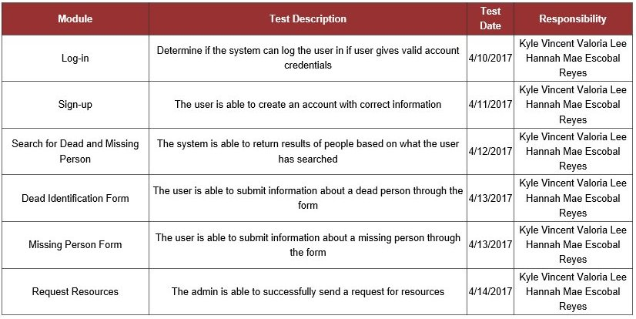

## [**e. Test Approach**](http://projects2.apc.edu.ph/wiki/index.php/Management_of_the_Dead_and_Missing_Person_System#Test_Approach)

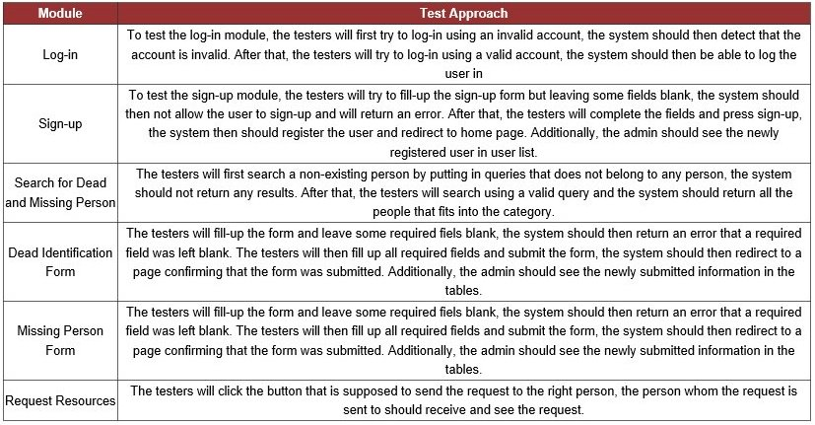This table elaborates how each module are going to be tested. Different modules have different ways of determining if it passed quality standards or not. It is stated in this table how the testers will test a certain module.

## **f. Test Pass/Fail Criteria**

The criteria for passing or failing a test is stated in this table. A module will only pass if it meets the criteria stated in the table, and fail if otherwise.

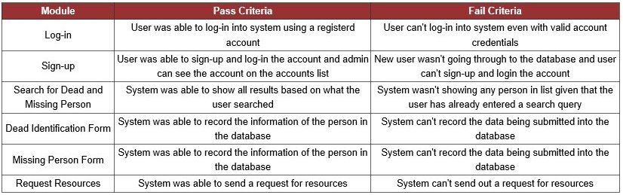

[**g. Test Entry/Exit Criteria**](http://projects2.apc.edu.ph/wiki/index.php/Management_of_the_Dead_and_Missing_Person_System#Test_Entry.2FExit_Criteria)

This table states what will be the entry point and exit point of a module. Taking the first module as an example, the user will only enter the Log-in module once a username and password is entered, then he/she will only exit the module once logged-in and redirected to the home page.

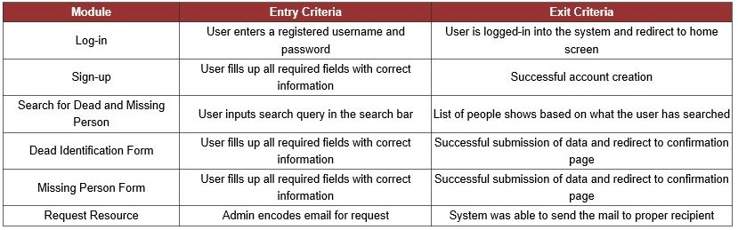

## [**h. Test Cases**](http://projects2.apc.edu.ph/wiki/index.php/Management_of_the_Dead_and_Missing_Person_System#Test_Cases)

### [**Log-in**](http://projects2.apc.edu.ph/wiki/index.php/Management_of_the_Dead_and_Missing_Person_System#Log-in_2)

|  |  |  |  |  |  |  |
| --- | --- | --- | --- | --- | --- | --- |
| **Project Name:** | Management of the Dead and the Missing Persons System | | **Module Name:** | Registration | | |
| **Test Designed by:** | Kyle Vincent V. Lee | | **Test Designed date:** | 4/14/17 | | |
| **Test Executed by:** | Hannah Mae E. Reyes | | **Test Execution date:** |  | | |
| **Test ID:** | R-002 | | **Test Title:** | Verify Login | | |
| **Test Priority:** | Medium | | **Test Description:** | Test the login system by entering a valid username and password. | | |
|  |  |  |  |  |  |  |
| **Pre-conditions:** | User should have an account with valid username and password. | | | | | |
| **Assumption:** | A supported browser is being used. | | | | | |
|  |  |  |  |  |  |  |
| **Step** | **Test Steps** | **Test Data** | **Expected Result** | **Actual Result** | **Pass/Fail** | **Remarks/ Corrective Action** |
| 1 | Navigate to the login page |  | The login page will show. | The login page showed. | Pass |  |
| 2 | In the username field, enter the username of the registered user | Email address: hereyes | The email field should be filled with a valid username. | The username field is filled | Pass |  |
| 3 | Enter the password of the registered user. | Password: 12345 | The password field should be filled with password data. | The password field is filled. | Pass |  |
| 4 | Click "Login" Button |  | After clicking the Login button, the user should be directed to the home page of the application. | The user is directed to the home page of the application. | Pass |  |
|  |  |  |  |  |  |  |
| **Post-condition:** | User is validated with database and successfully login to account. The account session details are logged in database. | | | | | |

### [**Sign-up**](http://projects2.apc.edu.ph/wiki/index.php/Management_of_the_Dead_and_Missing_Person_System#Sign-up_2)

|  |  |  |  |  |  |  |
| --- | --- | --- | --- | --- | --- | --- |
| **Project Name:** | Management of the Dead and the Missing Persons System | | **Module Name:** | Registration | | |
| **Test Designed by:** | Kyle Vincent V. Lee | | **Test Designed date:** | 4/14/17 | | |
| **Test Executed by:** | Hannah Mae E. Reyes | | **Test Execution date:** |  | | |
| **Test ID:** | R-001 | | **Test Title:** | Sign Up | | |
| **Test Priority:** | Medium | | **Test Description:** | Test the signup system by entering valid information. | | |
|  |  |  |  |  |  |  |
| **Pre-conditions:** | The user should know his/her valid information before creating an account. | | | | | |
| **Assumption:** | A supported browser is being used. | | | | | |
|  |  |  |  |  |  |  |
| **Step** | **Test Steps** | **Test Data** | **Expected Result** | **Actual Result** | **Pass/Fail** | **Remarks/ Corrective Action** |
| 1 | Navigate to sign-up page |  | The sign-up page will show | The sign-up page showed | Pass |  |
| 2 | In the first field, user inputs first name | First Name: Jon | The field returns an error if left blank | The field returns an error when left blank | Pass |  |
| 3 | In the second field, user inputs middle name | Middle Name: Rodriguez | The field returns an error if left blank | The field returns an error when left blank | Pass |  |
| 4 | In the third field, user inputs last name | Last Name: Gomez | The field returns an error if left blank | The field returns an error when left blank | Pass |  |
| 5 | In the fourth field, user inputs username | Username: jrgomez | The field returns an error if left blank | The field returns an error when left blank | Pass |  |
| 6 | In the fifth field, user selects gender | Gender:Male/Female | The field returns an error if user does not select anything | The field return an error when user didn't select anything | Pass |  |
| 7 | In the sixth field, user inputs birth date | Birthday: 01/14/1998 | The field returns an error if left blank | The field returns an error when left blank | Pass |  |
| 8 | In the seventh field, user inputs age | Age: 19 | The field returns an error if left blank | The field returns an error when left blank | Pass |  |
| 9 | In the eight field, user inputs phone number | Phone No.: 09123456789 | The field returns an error if left blank | The field returns an error when left blank | Pass |  |
| 10 | In the ninth field, user inputs address | Address: 2431 M. dela Cruz St., Pasay City | The field returns an error if left blank | The field returns an error when left blank | Pass |  |
| 11 | In the tenth field, user inputs email address | Email: jrgomez@gmail.com | The field returns an error if left blank | The field returns an error when left blank | Pass |  |
| 12 | In the last field, user inputs password | Password: 123456 | The field returns an error if left blank | The field returns an error when left blank | Pass |  |
| 13 | User clicks "signup" button |  | The system will check if all fields are filled and will automatically login user if signup is successful | System logs in user when signup is successful | Pass |  |
|  |  |  |  |  |  |  |
| **Post-condition:** | User already have an account in the database. | | | | | |

### [**Search for Dead**](http://projects2.apc.edu.ph/wiki/index.php/Management_of_the_Dead_and_Missing_Person_System#Search_for_Dead)

|  |  |  |  |  |  |  |
| --- | --- | --- | --- | --- | --- | --- |
| **Project Name:** | Management of the Dead and the Missing Persons System | | **Module Name:** | Search and Recovery | | |
| **Test Designed by:** | Kyle Vincent V. Lee | | **Test Designed date:** | 4/14/17 | | |
| **Test Executed by:** | Hannah Mae E. Reyes | | **Test Execution date:** |  | | |
| **Test ID:** | SR-001 | | **Test Title:** | Search for Dead Person | | |
| **Test Priority:** | High | | **Test Description:** | Searching of dead person’s information in the search bar with filter options | | |
|  |  |  |  |  |  |  |
| **Pre-conditions:** | There should be a dead person information in the database. | | | | | |
| **Assumption:** | Search bar is functioning. | | | | | |
|  |  |  |  |  |  |  |
| **Step** | **Test Steps** | **Test Data** | **Expected Result** | **Actual Result** | **Pass/Fail** | **Remarks/ Corrective Action** |
| 1 | Navigate to "Dead List" Page |  | The "Dead List" Page will show up | The "Dead List" page showed | Pass |  |
| 2 | Select filter in dropdown | By Upper Garment, By Lower Garment, By Skin Color | Dropdown list should contain choices that user can use to filter their search | Dropdown list worked | Pass |  |
| 3 | Enter search item in the search bar | Polo Shirt, Shirt, Pants, Orange Eyewear, Long Hair | System should be able to return the list of missing people that fits the searched item | System able to return the list of missing people that fits the searched item | Pass |  |
|  |  |  |  |  |  |  |
| **Post-condition:** | Dead person’s information must display. | | | | | |

### [**Search for Missing**](http://projects2.apc.edu.ph/wiki/index.php/Management_of_the_Dead_and_Missing_Person_System#Search_for_Missing)

|  |  |  |  |  |  |  |
| --- | --- | --- | --- | --- | --- | --- |
| **Project Name:** | Management of the Dead and the Missing Persons System | | **Module Name:** | Search and Recovery | | |
| **Test Designed by:** | Kyle Vincent V. Lee | | **Test Designed date:** | 4/14/17 | | |
| **Test Executed by:** | Hannah Mae E. Reyes | | **Test Execution date:** |  | | |
| **Test ID:** | SR-002 | | **Test Title:** | Search for Missing Person | | |
| **Test Priority:** | High | | **Test Description:** | Searching of dead person’s information in the search bar with filter options | | |
|  |  |  |  |  |  |  |
| **Pre-conditions:** | There should be a missing person information in the database. | | | | | |
| **Assumption:** | Search bar is functioning. | | | | | |
|  |  |  |  |  |  |  |
| **Step** | **Test Steps** | **Test Data** | **Expected Result** | **Actual Result** | **Pass/Fail** | **Remarks/ Corrective Action** |
| 1 | Navigate to "Missing List" Page |  | The "Missing List" Page will show up | The "Missing List" page showed | Pass |  |
| 2 | Select filter in dropdown | By Upper Garment, By Lower Garment, By Skin Color | Dropdown list should contain choices that user can use to filter their search | Dropdown list worked | Pass |  |
| 3 | Enter search item in the search bar | Polo Shirt, Shirt, Pants, Orange Eyewear, Long Hair | System should be able to return the list of missing people that fits the searched item |  |  |  |
|  |  |  |  |  |  |  |
| **Post-condition:** | Missing person’s information must display. | | | | | |

### [**Dead Identification Form**](http://projects2.apc.edu.ph/wiki/index.php/Management_of_the_Dead_and_Missing_Person_System#Dead_Identification_Form)

|  |  |  |  |  |  |  |
| --- | --- | --- | --- | --- | --- | --- |
| **Project Name:** | Management of the Dead and the Missing Persons System | | **Module Name:** | Identification of the Dead | | |
| **Test Designed by:** | Kyle Vincent V. Lee | | **Test Designed date:** | 4/14/17 | | |
| **Test Executed by:** | Hannah Mae E. Reyes | | **Test Execution date:** |  | | |
| **Test ID:** | IDF-001 | | **Test Title:** | Dead Identification Form | | |
| **Test Priority:** | High | | **Test Description:** | Test the dead identification form by entering valid set of data. | | |
|  |  |  |  |  |  |  |
| **Pre-conditions:** | There should be an information of dead body. | | | | | |
| **Assumption:** | A dead identification form is being used. | | | | | |
|  |  |  |  |  |  |  |
| **Step** | **Test Steps** | **Test Data** | **Expected Result** | **Actual Result** | **Pass/Fail** | **Remarks/ Corrective Action** |
| 1 | Navigate to "Dead Identification Form" Page |  | Redirect to "Dead Identification Form" Page | System redirected to "Dead Identification Form" Page | Pass |  |
| 2 | Select "General Condition" | Complete Body, Incomplete, etc. | User should be able to pick from a dropdown list | Dropdown list worked and user was able to pick a choice | Pass |  |
| 3 | Select "Body Condition" | Decomposed, Well preserved, etc. | User should be able to pick from a dropdown list | Dropdown list worked and user was able to pick a choice | Pass |  |
| 4 | Select "Apparent Sex" | Male, Female, Undetermined | User should be able to pick from a dropdown list | Dropdown list worked and user was able to pick a choice | Pass |  |
| 5 | Select "Age Group" | Infant, Child, Adult, etc. | User should be able to pick from a dropdown list | Dropdown list worked and user was able to pick a choice | Pass |  |
| 6 | Select "Height" | Short, Tall, Average | User should be able to pick from a dropdown list | Dropdown list worked and user was able to pick a choice | Pass |  |
| 7 | Select "Weight" | Slim, Average, Obese | User should be able to pick from a dropdown list | Dropdown list worked and user was able to pick a choice | Pass |  |
| 8 | Select "Hair Length" | Bald, Short, Medium, Long | User should be able to pick from a dropdown list | Dropdown list worked and user was able to pick a choice | Pass |  |
| 9 | Select "Hair Color" | Black, Blonde, etc. | User should be able to pick from a dropdown list; this field should disappear if hair length is bald | Dropdown list worked and user was able to pick a choice; field disappeared when selected hair length is bald | Pass |  |
| 10 | Select "Facial Hair Type" | Mustache, Beard, None | User should be able to pick from a dropdown list | Dropdown list worked and user was able to pick a choice | Pass |  |
| 11 | Select "Facial Hair Length" | Short, Medium, Long | User should be able to pick from a dropdown list; this field should disappear if facial hair type is none | Dropdown list worked and user was able to pick a choice; field disappeared when selected facial hair type is none | Pass |  |
| 12 | Select "Facial Hair Color" | Black, Blonde, etc. | User should be able to pick from a dropdown list; this field should disappear if facial hair type is none | Dropdown list worked and user was able to pick a choice; field disappeared when selected facial hair type is none | Pass |  |
| 13 | Select what skin marks does person have | Scars, Tattoos, Birthmarks, Moles | User should be able to pick one or many choices and skin mark location choices should appear when a choice is selected | User was able to select from choices and skin mark location choices appeared | Pass |  |
| 14 | Clicks "Next" button |  | Form should return an error if there is a required field left blank and transition to next part if complete | Form transitions to next part when all required fields are filled and returns an error if not | Pass |  |
| 15 | Select "Upper Garment" | Shirt, Polo Shirt, etc. | User should be able to pick from a dropdown list and color fields should show when choice is picked | Dropdown list worked and user was able to pick a choice and color choice showed when a choice is picked | Pass |  |
| 16 | Select "Lower Garment" | Jeans, Shorts, etc. | User should be able to pick from a dropdown list and color fields should show when choice is picked | Dropdown list worked and user was able to pick a choice and color choice showed when a choice is picked | Pass |  |
| 17 | Select "Footwear" | Sandals, Shoes, Slippers, etc. | User should be able to pick from a dropdown list | Dropdown list worked and user was able to pick a choice | Pass |  |
| 18 | Select "Eyewear" | Contact Lens, Glasses | User should be able to pick from a dropdown list and color fields should show when either choice is picked | Dropdown list worked and user was able to pick a choice and color choice showed when either choice is picked | Pass |  |
| 19 | Clicks "Next" button |  | Form should return an error if there is a required field left blank and transition to next part if complete | Form transitions to next part when all required fields are filled and returns an error if not | Pass |  |
| 20 | User selects if to "Upload Picture" or "Take a Picture" | Picture | System should be able to access camera if take a picture is picked and user should be able to upload a picture if upload a picture is picked | User was able to upload a picture and/or take a picture | Pass |  |
|  |  |  |  |  |  |  |
| **Post-condition:** | The form should be finished and submitted. The information in the form is submitted in the database. | | | | | |

### [**Missing Person Form**](http://projects2.apc.edu.ph/wiki/index.php/Management_of_the_Dead_and_Missing_Person_System#Missing_Person_Form)

|  |  |  |  |  |  |  |
| --- | --- | --- | --- | --- | --- | --- |
| **Project Name:** | Management of the Dead and the Missing Persons System | | **Module Name:** | Management of the Missing Persons | | |
| **Test Designed by:** | Kyle Vincent V. Lee | | **Test Designed date:** | 4/14/17 | | |
| **Test Executed by:** | Hannah Mae E. Reyes | | **Test Execution date:** |  | | |
| **Test ID:** | MMP-001 | | **Test Title:** | Missing Person Form | | |
| **Test Priority:** | High | | **Test Description:** | Test the missing person form by entering valid set of data. | | |
|  |  |  |  |  |  |  |
| **Pre-conditions:** | There should be an information of missing person. | | | | | |
| **Assumption:** | A missing person form is being used. | | | | | |
|  |  |  |  |  |  |  |
| **Step** | **Test Steps** | **Test Data** | **Expected Result** | **Actual Result** | **Pass/Fail** | **Notes** |
| 1 | Navigate to "Missing Person Form" |  | System will redirect to "Missing Person Form" Page | System redirected to "Missing Person Form" Page | Pass |  |
| 2 | Click "Select Image" button | Sample Picture | User should be able to select a picture to upload | User was able to select picture | Pass |  |
| 3 | Fill up name fields | Sample Name | User should be able to input name | User was able to input name | Pass |  |
| 4 | Fill up address field | Sample Address | User should be able to input address | User was able to input address | Pass |  |
| 5 | Select "Marital Status" | Single, Married, etc. | User should be able to pick from a dropdown list | Dropdown list worked and user was able to pick a choice | Pass |  |
| 6 | Select "Sex" | Male, Female | User should be able to pick from a dropdown list | Dropdown list worked and user was able to pick a choice | Pass |  |
| 7 | Select "Date of Birth of Missing Person" | 1/14/1998 | User should be able to either pick a date from date picker or input date in fields | Date picker is working and user can also input date in fields | Pass |  |
| 8 | Fill up "Age" | 19 | Field should be automatically computed and filled based on birth date | Field was automatically computed and field | Pass |  |
| 9 | Fill "Occupation" | Student, Carpenter, Doctor, etc. | User should be able to input occupation | User was able to input occupation | Pass |  |
| 10 | Clicks "Next" button |  | Form should return an error if there is a required field left blank and transition to next part if complete | Form transitions to next part when all required fields are filled and returns an error if not | Pass |  |
| 11 | Select "Date and Time of Disappearance" | 1/15/2017  10:10:10 AM | User should be able to either pick a date from date picker or input date in fields | Date picker is working and user can also input date in fields | Pass |  |
| 12 | Select or input "Place where person is last seen" | Makati City | User should be able to move the marker using the map to pinpoint location or input address | User was able to move marker on the map and/or input address | Pass |  |
| 13 | Select "Relationship with Person" | Father, Mother, etc. | User should be able to pick from a dropdown list | Dropdown list worked and user was able to pick a choice | Pass |  |
| 14 | Clicks "Next" button |  | Form should return an error if there is a required field left blank and transition to next part if complete | Form transitions to next part when all required fields are filled and returns an error if not | Pass |  |
| 15 | Select "Height" | Short, Average, Tall | User should be able to pick from a dropdown list | Dropdown list worked and user was able to pick a choice | Pass |  |
| 16 | Select "Weight" | Slim, Average, Obese | User should be able to pick from a dropdown list | Dropdown list worked and user was able to pick a choice | Pass |  |
| 17 | Select "Eye Color" | Brown, Blue, Green, etc. | User should be able to pick from a dropdown list | Dropdown list worked and user was able to pick a choice | Pass |  |
| 18 | Select "Hair Length" | Bald, Short, Medium, Long | User should be able to pick from a dropdown list | Dropdown list worked and user was able to pick a choice | Pass |  |
| 19 | Select "Hair Color" | Black, Blonde, etc. | User should be able to pick from a dropdown list; this field should disappear if hair length is bald | Dropdown list worked and user was able to pick a choice; field disappeared when hair length selected is bald | Pass |  |
| 20 | Select "Facial Hair Type" | Mustache, Beard | User should be able to pick from a dropdown list | Dropdown list worked and user was able to pick a choice | Pass |  |
| 21 | Select "Facial Hair Color" | Black, Blonde, etc. | User should be able to pick from a dropdown list; this field should disappear if facial hair type is none | Dropdown list worked and user was able to pick a choice; field disappeared when facial hair type selected is none | Pass |  |
| 22 | Select "Facial Hair Length" | Short, Medium, Long | User should be able to pick from a dropdown list; this field should disappear if facial hair type is none | Dropdown list worked and user was able to pick a choice; field disappeared when facial hair type selected is none | Pass |  |
| 23 | Select "Shape of Ears" | Round, Pointed, etc. | User should be able to pick from a dropdown list | Dropdown list worked and user was able to pick a choice | Pass |  |
| 24 | Select "Eyebrows" | Thin, Thick, Other | User should be able to pick from a dropdown list | Dropdown list worked and user was able to pick a choice | Pass |  |
| 25 | Select "Nose" | Small, Average, Large | User should be able to pick from a dropdown list | Dropdown list worked and user was able to pick a choice | Pass |  |
| 26 | Select "Hands" | Small, Average, Large | User should be able to pick from a dropdown list | Dropdown list worked and user was able to pick a choice | Pass |  |
| 27 | Select "Feet" | Small, Average, Large | User should be able to pick from a dropdown list | Dropdown list worked and user was able to pick a choice | Pass |  |
| 28 | Select what skin marks does person have | Scars, Tattoos, Birthmarks, Moles | User should be able to pick one or many choices and skin mark location choices should appear when a choice is selected | User was able to select from choices and skin mark location choices appeared | Pass |  |
| 29 | Select "Upper Garment" | Shirt, Polo Shirt, etc. | User should be able to pick from a dropdown list and color fields should show when choice is picked | Dropdown list worked and user was able to pick a choice and color choice showed when a choice is picked | Pass |  |
| 30 | Select "Lower Garment" | Shorts, Jeans, etc. | User should be able to pick from a dropdown list and color fields should show when choice is picked | Dropdown list worked and user was able to pick a choice and color choice showed when a choice is picked | Pass |  |
| 31 | Select "Footwear" | Sandals, Shoes, Slippers, etc. | User should be able to pick from a dropdown list | Dropdown list worked and user was able to pick a choice | Pass |  |
| 32 | Select "Eyewear" | Contact Lens, Glasses | User should be able to pick from a dropdown list and color fields should show when either choice is picked | Dropdown list worked and user was able to pick a choice and color choice showed when either choice is picked | Pass |  |
| 32 | Click "Submit" |  | System should show confirmation page and form should be able to submit data into database assuming all fields are filled. | System showed confirmation page and data was submitted to database | Pass |  |
|  |  |  |  |  |  |  |
| **Post-condition:** | The form should be finished and submitted. The information in the form is submitted in the database. | | | | | |

### [**Request Resource**](http://projects2.apc.edu.ph/wiki/index.php/Management_of_the_Dead_and_Missing_Person_System#Request_Supplies)

|  |  |  |  |  |  |  |
| --- | --- | --- | --- | --- | --- | --- |
| **Project Name:** | Management of the Dead and the Missing Persons System | | **Module Name:** | Final Arrangement of Dead | | |
| **Test Designed by:** | Kyle Vincent V. Lee | | **Test Designed date:** | 4/14/17 | | |
| **Test Executed by:** | Hannah Mae E. Reyes | | **Test Execution date:** |  | | |
| **Test ID:** | RR-001 | | **Test Title:** | Request Resource | | |
| **Test Priority:** | Medium | | **Test Description:** | Test by clicking the button to be able to send an email | | |
|  |  |  |  |  |  |  |
| **Pre-conditions:** | The e-mail must be properly composed. | | | | | |
| **Assumption:** | The request resource button is functioning. | | | | | |
|  |  |  |  |  |  |  |
| **Step** | **Test Steps** | **Test Data** | **Expected Result** | **Actual Result** | **Pass/Fail** | **Remarks/ Corrective Action** |
| 1 | Navigate to "Dead Posts" in backend |  | The "Dead Posts" page will show | The "Dead Posts" page showed | Pass |  |
| 2 | Click "Request for Resources" button | E-mail | System should be able to send an email to right person and should return a confirmation that the email was sent | System was able to send email to person but was not able to show confirmation to sender | Fail | Add confirmation text that the email was sent |
|  |  |  |  |  |  |  |
| **Post-condition:** | The recipient should receive the e-mail. | | | | | |

## [**i. Number of Items Tested**](http://projects2.apc.edu.ph/wiki/index.php/Management_of_the_Dead_and_Missing_Person_System#Number_of_Items_Tested)

### [**Number of Pass Tests**](http://projects2.apc.edu.ph/wiki/index.php/Management_of_the_Dead_and_Missing_Person_System#Number_of_Pass_Tests)

### [**Number of Fail Tests**](http://projects2.apc.edu.ph/wiki/index.php/Management_of_the_Dead_and_Missing_Person_System#Number_of_Fail_Tests)

## [**j. Test Ratings**](http://projects2.apc.edu.ph/wiki/index.php/Management_of_the_Dead_and_Missing_Person_System#Test_Ratings)

Test Ratings are percentages computed to see what percent of the tests passed and what percent of the tests failed. Modules that have reached 85% and above rating is considered a pass.

### [**Pass Rate**](http://projects2.apc.edu.ph/wiki/index.php/Management_of_the_Dead_and_Missing_Person_System#Pass_Rate)

This table shows how many percent of the tests have passed.

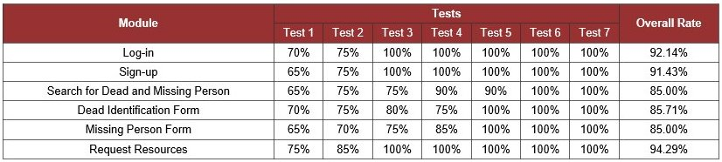

### [**Defect Rate**](http://projects2.apc.edu.ph/wiki/index.php/Management_of_the_Dead_and_Missing_Person_System#Defect_Rate)

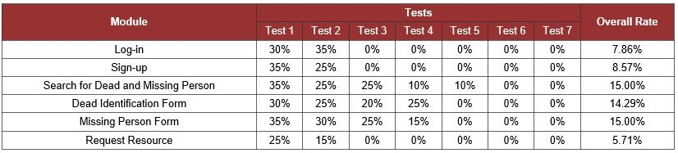This table shows how many percent of the tests failed.

## [**k. Test Results**](http://projects2.apc.edu.ph/wiki/index.php/Management_of_the_Dead_and_Missing_Person_System#Test_Results)

### [**Overall Results**](http://projects2.apc.edu.ph/wiki/index.php/Management_of_the_Dead_and_Missing_Person_System#Overall_Results)

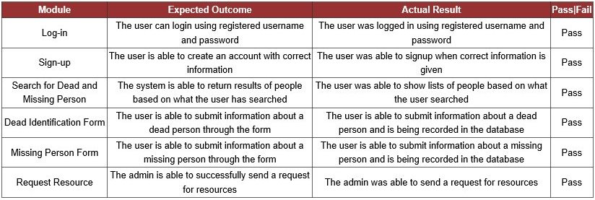

# [**V. Appendices**](http://projects2.apc.edu.ph/wiki/index.php/Management_of_the_Dead_and_Missing_Person_System#Appendices)

## combine_imagesk_zpshe5g7h0k.jpg[**Appendix 1: Curriculum Vitae**](http://projects2.apc.edu.ph/wiki/index.php/Management_of_the_Dead_and_Missing_Person_System#Appendix_1:_Curriculum_Vitae)

